Wisconsin Concussion Fact Sheet for Athletes

Assess the situation
Be alert for signs and symptoms
Contact a health care provider

What are the signs and symptoms of a concussion?
Unlike a broken arm, you can’t see a concussion. Mo st
con cu ssion s o ccu r wi thout loss of con sciou sne ss. Signs

What is a concussion?

A concussion is a type of brain injury that changes the way the brain normally works. A concussion is
caused by a bump, blow, or jolt to the head. Concussions can also occur from a blow to the body that causes the head and brain to move rapidly back and forth. Even what seems to be a mild bump to the head can be serious. Concussions can occur during practices or games in any
sport or recreational activity.
and symptoms of concussion can show up right after an injury or may not appear or be noticed until hours or days after the injury. It is important to watch for changes in how you are feeling, if symptoms are getting worse, or if you just “don’t feel right.” If you think you or a teammate may have a concussion, it is important to tell someone.

COMMON SYMPTOMS OF A CONCUSSION:
Tell someone if you see a teammate Tell someone if you feel any of the following:

SIGNS OBSERVED BY SYMPTOMS REPORTED BY YOUR CHILD OR TEEN PARENTS OR GUARDIANS
with any of these symptoms:

• Appears dazed or stunned
• Forgets sports plays
• Is confused about assignment or position
• Moves clumsily
• Answers questions slowly
• Repeats questions
• Can’t recall events prior to the hit, bump, or fall
• Can’t recall events after the
hit, bump, or fall
• Loses consciousness
(even briefly)
• Shows behavior or personality changes
Thinking/Remembering:
• Difficulty thinking clearly
• Difficulty concentrating or remembering
• Feeling more slowed down
• Feeling sluggish, hazy, foggy, or groggy

Physical:
• Headache or “pressure” in head
• Nausea or vomiting
• Balance problems or dizziness
• Fatigue or feeling tired
• Blurry or double vision
• Sensitivity to light or noise
• Numbness or tingling
• Does not “feel right”
Emotional:
• Irritable
• Sad
• More emotional than usual
• Nervous

Changes in your normal sleep patterns.

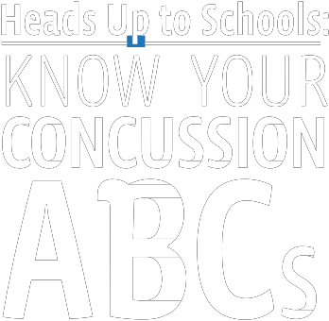
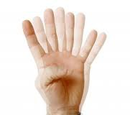

Materials adapted from the U.S. Department of Health and Human Services Centers for Disease Control a nd P r e v e nt i on

*Wear the proper

equipment for each sport and make sure it fits well.
*Follow the rules of the sport and the coach’s rule for safety.

*Use proper technique.
If you have a suspected concussion, you should NEVER return to sports or recreational activities on the same day the injury occurred. You should not return to activities until you are symptom-free and a health care provider experienced in managing concussion
provides written clearance allowing return to activity. This means, until permitted, not returning to:
• Physical Education (PE) class,
• Sports conditioning, weight lifting, practices and games, or
• Physical activity at recess.

What should you do if you think you have a concussion?

1. Tell your coaches and parents right away. Never ignore a bump or blow to the head even if you feel fine. If you experience symptoms of a concussion, you should immediately remove yourself from practice/play. Tell your coach right away if you think you or one of your teammates might have a concussion.

2. Get evaluated by a health care provider. A health care provider experienced in evaluating for concussion can determine if you have a
concussion, help guide management and safe return to normal activities, including school (concentration and learning) and physical activity. If you have been removed from a youth athletic activity because of a suspected or confirmed concussion or head injury you may not participate again until evaluated by a health care provider and you receive written clearance to return to activity. You must provide this written clearance to your coach.

3. Give yourself time to get better. If you have had a concussion, your brain needs to time to heal.
While your brain is still healing, you are much more likely to have a repeat concussion. It is important
to rest until you receive written clearance from a health care provider to return to practice and play.
Why should you tell someone about your symptoms?
1. Your chances of sustaining a life altering injury are greatly increased if you aren’t fully recovered from a concussion or head injury.
2. Practicing/playing with concussion symptoms can prolong your recovery.
3. Practicing/playing with a concussion can increase your chances of getting another concussion.
4. Telling someone could save your life or the life of a teammate!

Tell your teachers
Tell your teachers if you have suffered a concussion or head injury. Concussions often impair school performance. In order to properly rest, many students often need to miss a few days of school immediately following a concussion. When you return to school after a concussion you may need to:
• Take rest breaks as needed,
• Spend fewer hours at school,
• Have more time allowed to take tests or complete assignments,
• Suspend your physical activity (PE class and/or recess)
• Suspend your extracurricular activities (band, choir, dance, etc)
• Reduce time spent reading, writing, or on the computer.

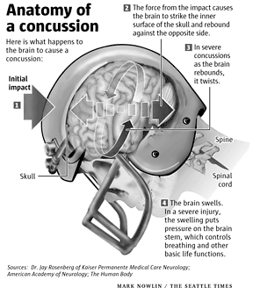

To learn more about concussions, go to:
www.cdc.gov/Concussion; www. wia a wi. o r g ; w w w.n f h s .o r g

